This is a request under the Freedom of Information Act 2000.
I am researching what patients in England are told about the risks of surgery to the inferior turbinates. I would be grateful for the following:
1. A copy of the standard consent form, or the standard procedure-specific consent form, used by your ENT department for septoplasty with inferior turbinate reduction (turbinoplasty). If your department uses a generic Consent Form 1 with risks written by hand, please say so, and provide any pre-printed risk list, sticker, or proforma used alongside it.

The ENT department now used the OUH trust portal / login for the concentric app. This is a standardised national template for septoplasty +/- inferior turbinate reduction -that can be individualised for each pt.
Website: https://app.concentric.health/

Screen shot of template.
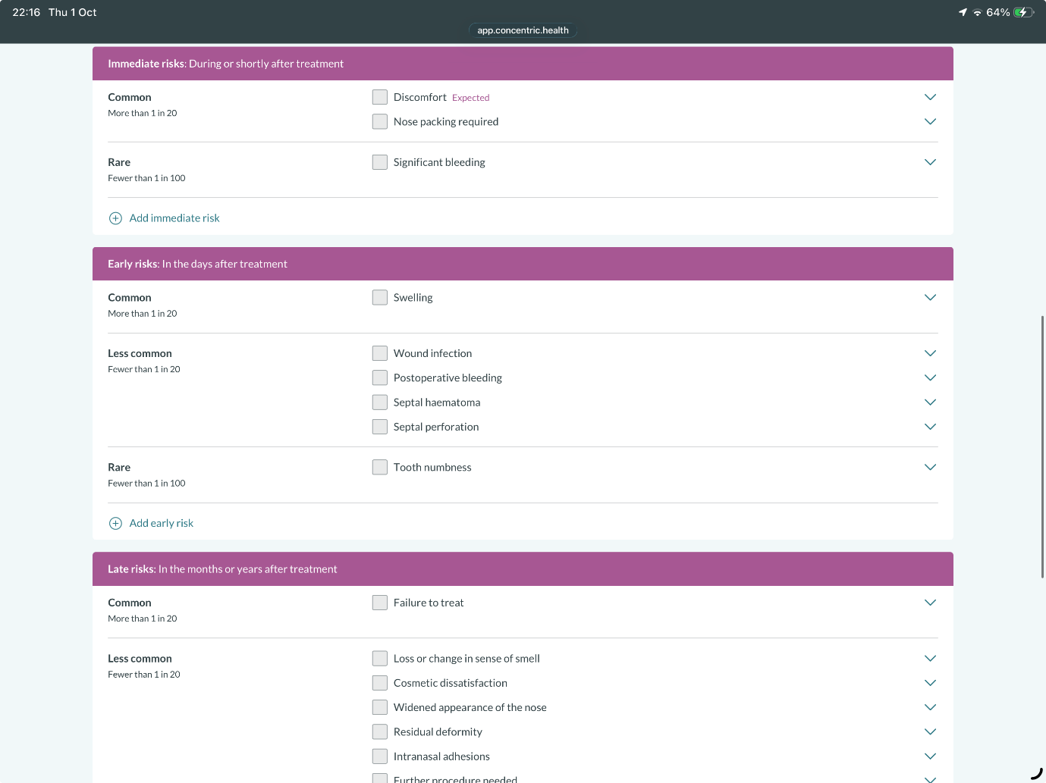
2. A copy of any patient information leaflet your trust provides to patients undergoing that procedure. If your trust directs patients to a third party's leaflet, such as the ENT UK patient information leaflets, please say which.

We use the ENT UK septoplasty and inferior turbinate leaflets - which are publicly available and linked on concentric or provided online.

https://www.entuk.org/patients/conditions/62/septal_surgery

