REQUEST: 1. I would like to request the numbers of midwifery students in the unit in the years 2021,2022,2023,2024,2025.
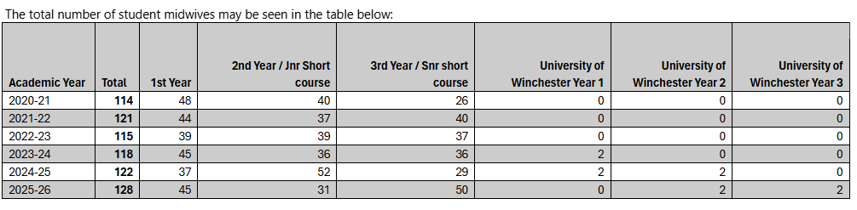
2. I would also like to request the number of qualified midwives employed in the same periods (both full time equivalent numbers and total number of all midwives regardless of contracted hours) with a breakdown per area of work.
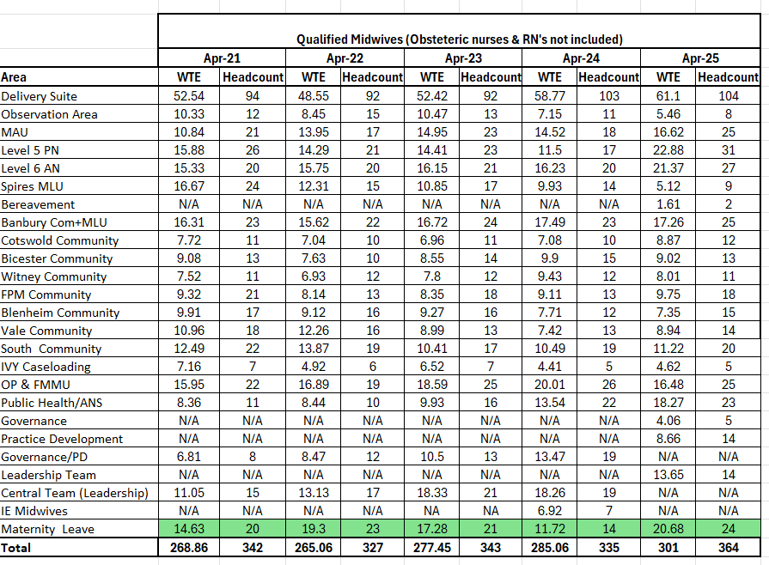
3. I would like to request the number of midwives qualified to supervise students in the same period (2021 to 2025).
This data is not held, however the service advise that it will be the exact same numbers as the number of qualified midwives employed during this time period. As all midwives who qualified after 2019 will have qualified supervisor ready and any midwives employed before this time will have been offered practice supervisor training or transition from mentorship model as part of the NMC move to the Triple SA model of supervision on 2019.
4. I would also like to request the numbers of formal complaints in the same period (2021-2025) with a breakdown of which area the complaints related to.


