RE: TME outcome of Sonographer paper

Hi ██████,
It was the 26th Feb TME meeting; please find both attached,
All the best,
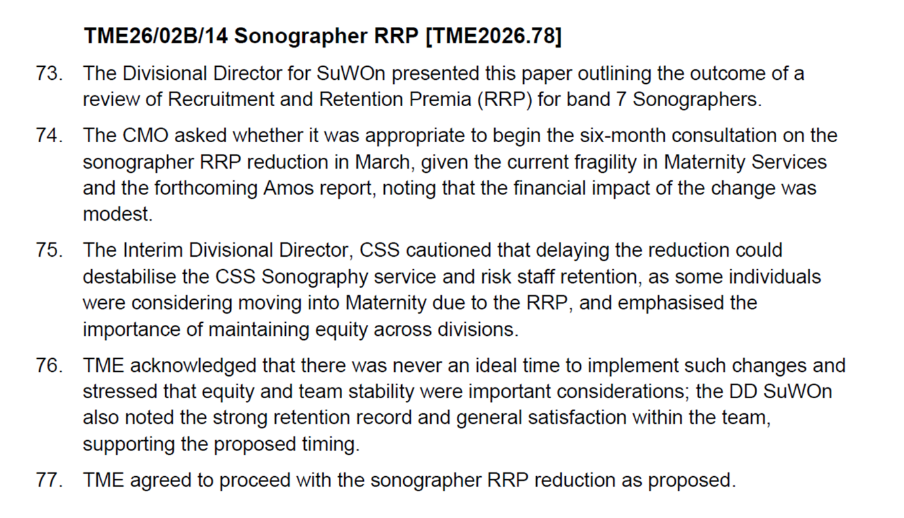
All the best,

██████, ██████,
Surgery, Women’s & Oncology Division

Oxford University Hospitals NHS Foundation Trust
Cancer & Haematology Centre (Level 2)
Churchill Hospital
Old Road
Headington
Oxford OX3 7LE

Telephone Number: ██████,
Mobile Number: ██████,

Working from Monday to Friday from 08:00 – 16:00



This E-mail and any attachments are strictly confidential and intended solely for the addressee or organization. If you are not the intended recipient(s), you must not disclose, forward, copy or take any action in reliance of this message or its attachments. If you have received this E-mail in error, please notify the sender immediately. Recipient(s) should also be aware that all E-mails received by this Trust are subject to the Freedom of Information Act 2000 and therefore may be disclosed to a third party.

From: ██████,
Sent: 17 March 2026 17:32
To: ██████,
Subject: TME outcome of Sonographer paper
Importance: High

Dear ██████,

Please can you send me a copy of the Sonographer TME paper and an excerpt from the TME minutes? I believe it went around end of January/beginning of February time this year. Thank you

Kind Regards

██████,

██████,, Surgery, Women’s and Oncology Division ██████,or via Microsoft Teams.

This email and any attachments are strictly confidential and intended solely for the addressee or organisation. If you are not the intended recipient you must not disclose, forward, copy or take any action in reliance of this message or its attachments. If you have received this message in error, please notify the sender immediately. The content of this email is subject to the Freedom of Information Act 2000 and may be disclosed to a third party.

